RSNA Outdoor Banners

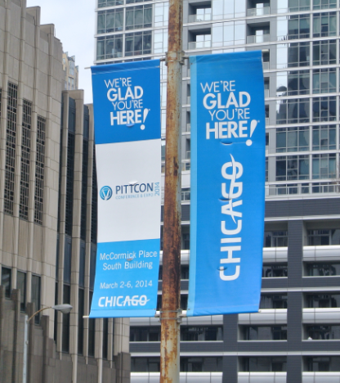
Street Banners

Street banners are a great way to welcome a group to the city. Following are details about the RSNA Outdoor Banner program.

Banner Size – Standard street banners are 30” wide by 99” tall. The live area for the banner design is 30” wide by 92” tall. Above and below the 92” area are 3.5” hems which are needed to attach the banners to the support arms on the light poles. Banners are double-sided.

Banner Design and Art Specifications - The city regulations require that the height of the sponsor illustration (graphics and/or words) be no larger than 10 inches tall and placed at the bottom of the banner. (There is no limit to the size of the RSNA’s name or logo within the banner.) Sponsored banners are typically the same design as the show banner, with the exception of the sponsor’s name or logo appearing in the bottom 10 inches of the banner. (See sample sponsored banners on following pages.)

Choose Chicago has banner templates available. (Please see samples on the following page.) You also have the choice of designing banners yourself. In general, art is prepared in Illustrator or In Design. Art can be prepared at full size, ½ size or ¼ size. Any fonts used in the design should be changed to outlines before the files are submitted. Colors can be referenced by pantone solid coated numbers. Any photographic images should be scanned at 300 dpi at ¼ size.

Banner Poles – Two banners are required per light pole. To help maximize the number of poles you utilize, Chicago “We’re Glad You’re Here!®” (CWGYH) banners are available to partner with the sponsor banner on the poles. CWGYH banners are red, blue, green and orange.

Banner Locations – Banner poles are located throughout the downtown area and by McCormick Place. The City of Chicago will provide approved locations one month prior to the event.

NOTE: All designs are subject to approval by RSNA, Choose Chicago and the City of Chicago.

Please email files to jswanson@rsna.org.
Sample Banners

RSNA Sponsor Banner Templates:

When the template is used for the show banner, a sponsor logo/name may be added in the bottom 10 inches of the banner for sponsored logos.
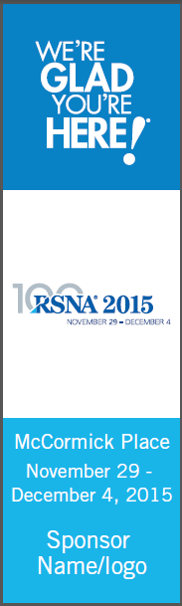
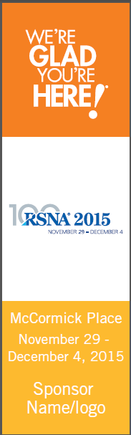
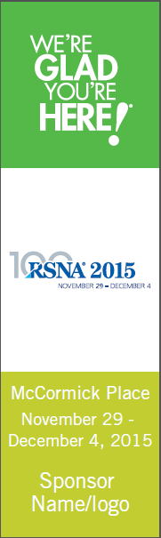
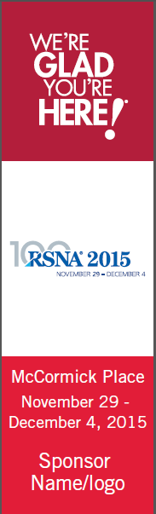

Chicago “We’re Glad You’re Here!®” Partner Banners

These banners are available to be installed on the street poles next to the show banners.
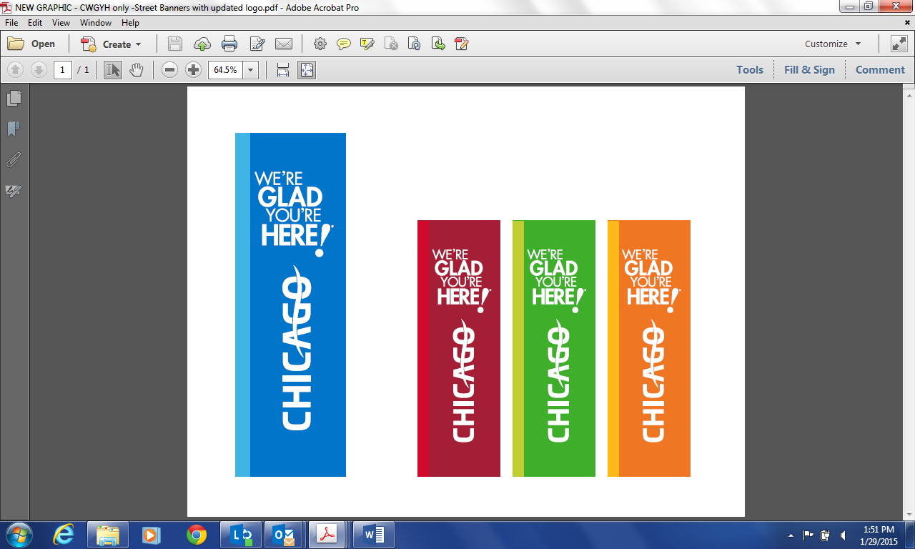

Samples of sponsored banners: Sample of banner designed by a show and their sponsored banner:
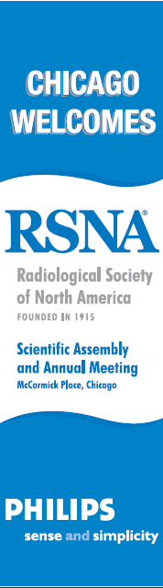
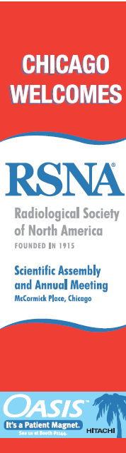
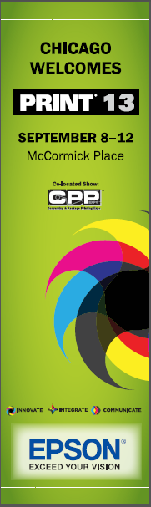
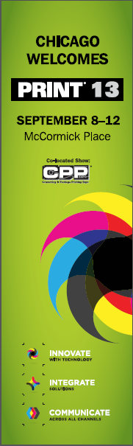


Note: Sponsor name/logo may be up to 10 inches high and placed at the bottom of the banner. Banner designs are subject to approval by RSNA, Choose Chicago and the City of Chicago.

